
Finance and Treasury Board
Contact Us

Economics and Statistics | Taxation | Budget |  | Financial Services | Insurance | Investor Relations | Publications | News | About Finance
Economics and Statistics  - Daily Stats  - Archived Daily Releases  - Subscribe to DailyStats    Use the Services Directory to quickly access information on all of the services provided by the NS Department of Finance.
  Home > Economics and Statistics > Archived Daily Stats > Selected Archived Daily Stats Article
  The Economics and Statistics Division maintains archives of previous publications for accountability purposes, but makes no updates to keep these documents current with the latest data revisions from Statistics Canada. As a result, information in older documents may not be accurate. Please exercise caution when referring to older documents. For the latest information and historical data, please contact the individual listed to the right.
  <--- Return to Archive
  For additional information relating to this article, please contact:
  Thomas Storring | Director – Economics and Statistics
  Tel: 902-424-2410 | Email: thomas.storring@novascotia.ca
  June 07, 2021
  DEATH COUNTS AND EXCESS MORTALITY, MARCH 2021
  The first death attributed to COVID-19 in Canada was reported in British Columbia occurring on March 8, 2020. COVID-19 has caused the death of 25,724 people in Canada.
  Statistics Canada has provided provisional information on deaths in Canada up to April 3, 2021. This includes deaths attributable to all causes; fluctuations from one week to the next may be attributable to many different causes of death. The data does not include all deaths that occurred during the reference period. Only Prince Edward Island, Quebec, Alberta and British Columbia have reported full information up to April 3, 2021. Information is not complete for recent weeks in:
  - Newfoundland and Labrador (to March 20)
  - Nova Scotia (to March 6)
  - New Brunswick (to February 27)
  - Ontario (to March 6)
  - Manitoba (to December 5)
  - Saskatchewan (to March 20)
  With limited information from several provinces, national estimates are available up to March 20.
  A comparison of deaths in 2020 and 2021 with the number of deaths reported in similar weeks in previous years allows highlights whether mortality is higher than usually observed at that time of year. The number of deaths reported in each week is represented below as a ratio of deaths per 1 million residents (population as of July 1 of the year - for 2021 the population as of July 1, 2020 is used). Based on observed historical trends, Statistics Canada has also estimated the expected number of deaths for each week and compared this with observed deaths (adjusted where possible reflecting provisional data). Estimates of expected deaths are presented with a 95 per cent confidence interval.
  There was a period of excess mortality in April and early May, concentrated in Quebec, Ontario, Alberta and British Columbia. There were also elevated deaths in Nova Scotia in the week ending April 25; Statistics Canada notes that deaths due to COVID-19 were reported in that week, but the total was affected by lives lost in the mass shooting on April 18-19. From May to July, the levels of deaths in all provinces fell.
  In the most current data, excess deaths were apparent in central and western provinces during the fall of 2020. However excess mortality has been abating in the winter months (January-March) among those provinces that had previously reported elevated numbers of deaths. In the most recent data, deaths per 1M residents were slightly elevated above pre-pandemic levels in Prince Edward Island, Alberta and British Columbia. There was no significant excess mortality estimated in any provinces reporting in February, March and April. Only Manitoba (whose data is only available up to December 5) reported significant excess mortality in its most recent results.
  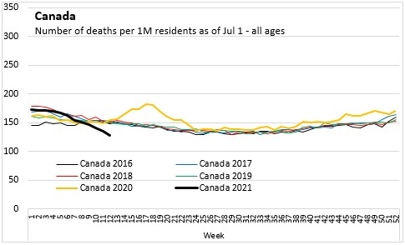
  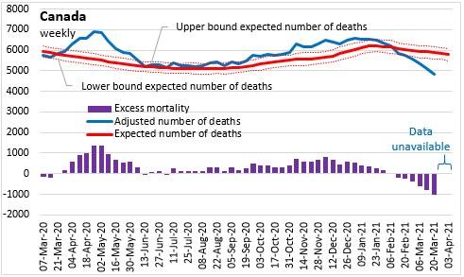
  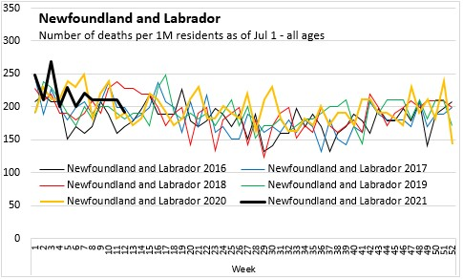
  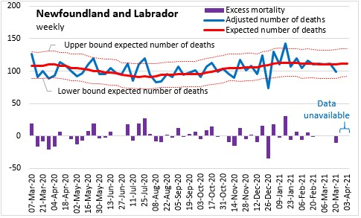
  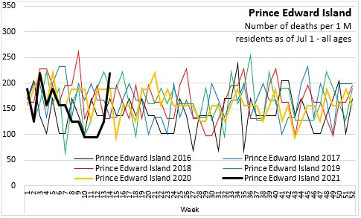
  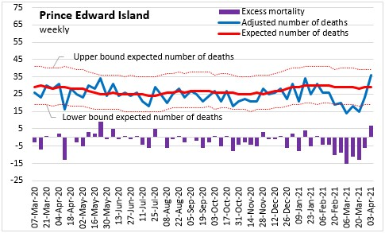
  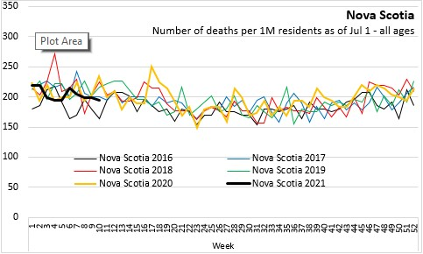
  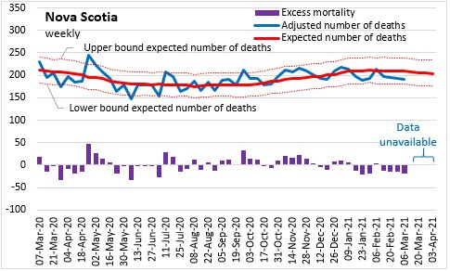
  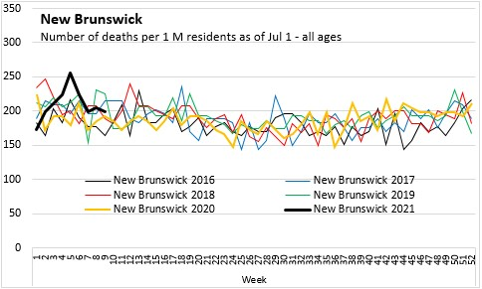
  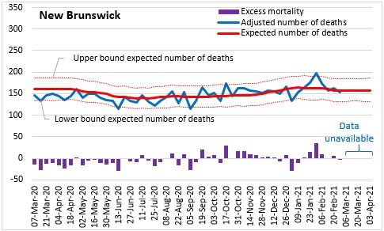
  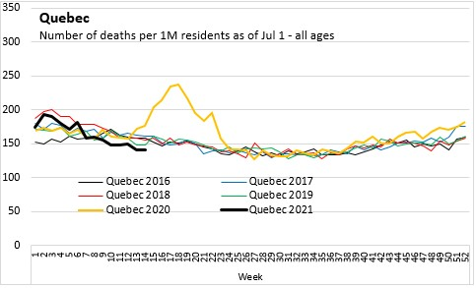
  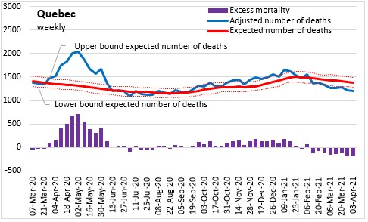
  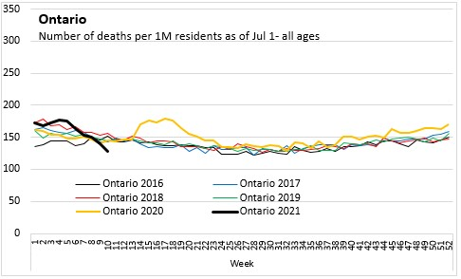
  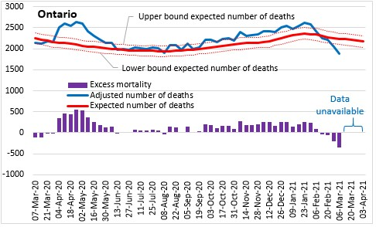
  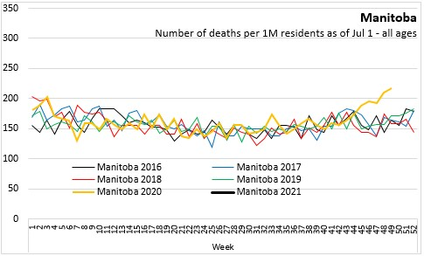
  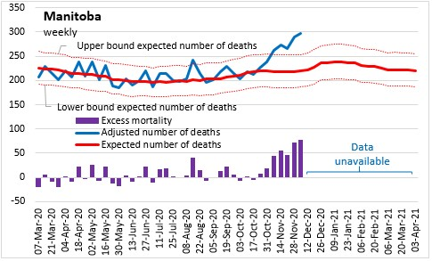
  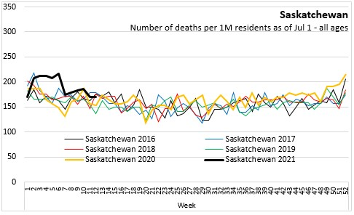
  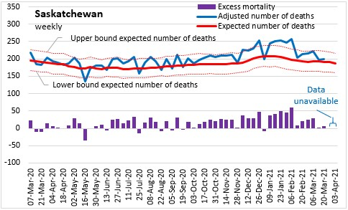
  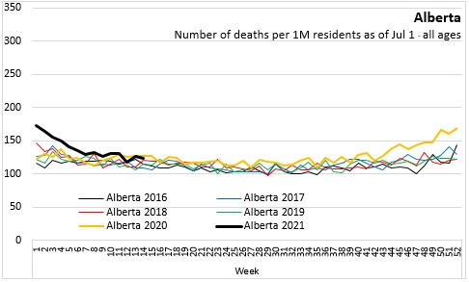
  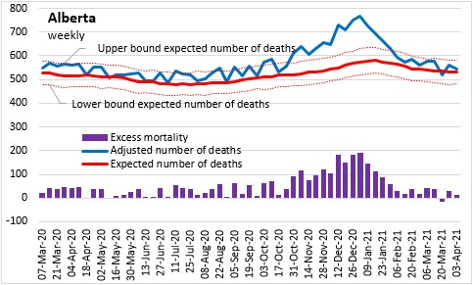
  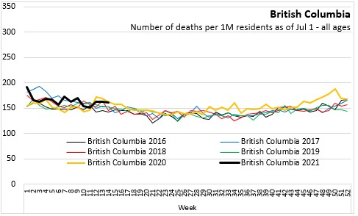
  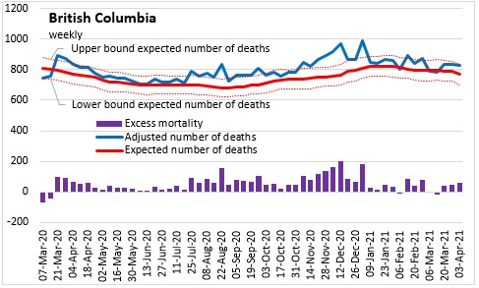
  Source: Statistics Canada. Table 13-10-0768-01 Weekly death counts, by age group and sex; Table 13-10-0784-01 Adjusted number of deaths, expected number of deaths and estimates of excess mortality, by week
  <--- Return to Archive

Privacy | Routine Access Policy
Crown copyright © Province of Nova Scotia

