The Health Protection Act Section 2 states: Restrictions on private rights and freedoms under this Act shall be no greater than are reasonably required, considering all of the circumstances, to respond to a health hazard, notifiable disease or condition, communicable disease or public health emergency. 2004,c.4,s.2.

Section 32 (1) states: Where a medical officer is of the opinion, upon reasonable and probable grounds, that:
(a) a communicable disease exists or may exist or that is an immediate risk of an outbreak of a communicable disease
(b) the communicable disease presents a risk to the public health; and
(c) the requirements specified in the order are necessary in order to decrease or eliminate the risk to the public health presented by the communicable disease

the Chief Medical Officer, Dr. Robert Strang has by written order required the unvaccinated to refrain from accessing to the following businesses, events and extra-curricular activities:
full-service restaurants, fast food coffee shops liquor licensed drinking establishments, bars, wineries, distillery tasting rooms, craft taprooms, liquor manufacturers, casinos, gaming establishments, fitness establishments, gyms, yoga studios, sport and recreation facilities, arenas, pools, large multipurpose recreation facilities, businesses and organizations offering indoor and outdoor recreation and leisure activities, climbing facilities, dance classes, escape rooms, go-carts, indoor arcades, indoor play spaces, music lessons, pottery painting, shooting ranges, holiday craft markets, outdoor adventure, indoor and outdoor festivals, special events and arts and culture events, theatre performances, concerts and movie theatres, indoor and outdoor sports practices, games, competitions and tournaments as participants and spectators, indoor and outdoor extracurricular school-based activities, including sports- bus, boat and walking tours, museums, Art Gallery of Nova Scotia, public library programs, indoor and outdoor events and activities like receptions, social events, conferences and training that are hosted by a business or organizations indoor and outdoor wedding ceremonies, funerals including receptions and visitation that are hosted by a business or organization, community meetings in rental spaces or where the public may be present, annual general meetings of businesses or organizations, training hosted by a business or organization, driver training or courses offered by a business that provides training - any training using a rental space, activities and events hosted by a faith organization like social time after a service, bible study, youth group, retreats, community meals, fundraisers or meetings, holiday concerts and special events, or activities and events held in rental spaces

Therefore, I would like to request the following:

1) All records, proof, evidence, studies, data – the circumstances that were considered - that support Dr. Robert Strang’s Orders made pursuant to Section 2 and 32 (1) of the Health Protection Act - are reasonable and required.

2. All proof that shows that COVID-19 is a “health hazard, notifiable disease or condition, communicable disease or public health emergency” that requires the restrictions above that remove our private rights and freedoms from entering businesses, events, and extracurricular activities. .

ull-service restaurants - fast food coffee shops liquor licensed drinking establishments - bars - wineries - distillery tasting rooms - craft taprooms - liquor manufacturers - casinos - gaming establishments - fitness establishments - gyms - yoga studios - sport and recreation facilities - arenas - pools - large multipurpose recreation facilities - businesses and organizations offering indoor and outdoor recreation and leisure activities - climbing facilities - dance classes - escape rooms - go-carts - indoor arcades - indoor play spaces - music lessons - pottery painting - shooting ranges - holiday craft markets - outdoor adventure - indoor and outdoor festivals - special events and arts and culture events - theatre performances - concerts and movie theatres - indoor and outdoor sports practices - games - competitions and tournaments as participants and spectators - indoor and outdoor extracurricular school-based activities, including sports- bus, boat and walking tours - museums - Art Gallery of Nova Scotia - public library programs - indoor and outdoor events and activities like receptions - social events - conferences and training that are hosted by a business or organizations indoor and outdoor wedding ceremonies - funerals including receptions and visitation that are hosted by a business or organization - community meetings in rental spaces or where the public may be present - annual general meetings of businesses or organizations - training hosted by a business or organization - driver training or courses offered by a business that provides training - any training using a rental space - activities and events hosted by a faith organization like social time after a service - bible study - youth group, retreats - community meals - fundraisers or meetings - holiday concerts and special events, or activities and events held in rental spaces

1. In this article:https://www.cbc.ca/news/canada/nova-scotia/nova-scotia-gospel-light-baptist-church-covid-outbreak-1.6250957 it states:

“Three people have died in the past week of COVID-19 — one at a group home in Amherst and two at a long-term care home in Pugwash, N.S. — and the province has said those cases trace back to the Gospel Light event.”

- I would like to request all records, reports, information, evidence, documentation, and proof - that supports this statement is true – that “three people died of COVID-19 and that “those cases (deaths) trace back to the Gospel Light event.” Please note – I do not want any identifying information. I am just seeking the body of evidence that support this statement by the province.

2. In this article it states that “Community spread in Nova Scotia's northern and western health zones is primarily associated with that event, according to the province.”

- All records that show how the government determines that “community spread” is “primarily associated” with an events.

3. In this article:https://www.cbc.ca/news/canada/nova-scotia/nova-scotia-gospel-light-baptist-church-covid-outbreak-1.6250957 it states:

“Three people have died in the past week of COVID-19 — one at a group home in Amherst and two at a long-term care home in Pugwash, N.S. — and the province has said those cases trace back to the Gospel Light event.”

- I would like to receive all reports and records that explain (a) the process taken to determine “community spread” (b) and the accuracy of “community spread”(c) the process taken to determine “contract tracing” (d) and the accuracy of contact tracing.

- Any record, briefing notes, e-mails, correspondence, report that was forwarded from Dr. Robert Strang’s Public Health office to the Office of the Premier and vice versa concerning this event.

4. Please provide all records, studies, data, evidence, reports that are held by Dr. Robert Strang’s office that proves that unvaccinated people (no shots – zero – vaccine free people) spread the COVID-19 virus to other people in Nova Scotia.

5. Please provide all records, studies, data, evidence, and reports that prove that this is a “disease of the unvaccinated (people who have had no shots (0) zero. are harming the health care system in Nova Scotia.

All records that support that vaccine free people are a health hazard, are spreading a notifiable disease or condition, a communicable disease or pose a public health emergency more so than those who are vaccinated.

6. Please provide all records, studies, data, evidence, reports on the extent to which the vaccine free/unvaccinated are harming the health care system in Nova Scotia.
Please note, there have been vaccine injuries that have required hospital visits, hospitalizations and ICU hospitalizations. Please include the numbers and data on adverse events following immunization that have required hospitalization, ICU hospitalization, emergency visit.

7. The number of unvaccinated people (no shots (0) - ZERO) that have been hospitalized (general and ICU) due to COVID-19 ONLY.

8. Please provide the number of people who have a) made a hospital visit b) been admitted into hospital c) been admitted into ICU for COVID-19 only

9. Please provide the number of people who were admitted for other reasons – for example, cancer, heart attack, surgery, who were tested in the hospital setting and tested positive for COVID-19

10. Of those who tested positive in hospital, please provide a breakdown of a) asymptomatic b) symptomatic.

11. Please provide the total number of people who tested positive with COVID-19 and died who were in Long Term Care, a nursing home, or were transferred from LTC or a nursing home and died in hospital. Please note how many people who died were at the end of life as per the FOIPOP:

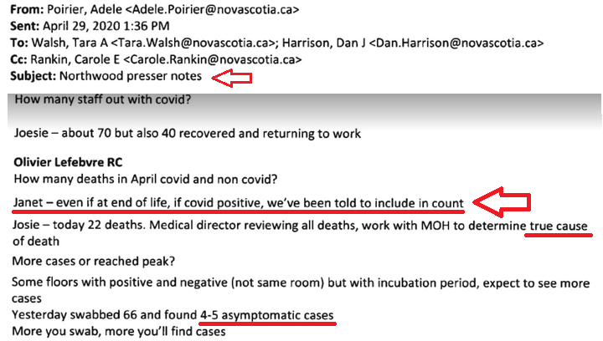

3. Please provide all records linking - through contact tracing and or community spread:
- Religious events:
a) Number of COVID-19 cases linked to religious events
b) Number of COVID-19 hospitalizations linked to religious events
c) Number of COVID-19 deaths linked to religious events
- Attending school:
a) Number of COVID-19 cases as a result of attending school.
b) Number of COVID-19 hospitalizations as a result of attending school.
c) Number of COVID-19 deaths as a result of attending school.
- Going to a restaurant:
a) Number of COVID-19 cases as a result of going to a restaurant.
b) Number of COVID-19 hospitalizations as a result of going to a restaurant.
c) Number of COVID-19 deaths as a result of going to a restaurant.
Please breakdown the total COVID-19 deaths by year (2020, 2021) into
a) Number that died at Long Term Care
    - Long Term Care who died at the LTC facility/nursing home and
    - Were transferred from the LTC facility/nursing home to hospital/or home to die
b) Number that were considered at the end of life. (Northwood Presser Notes)
c) Age ranges of those who died 0-19, 20-29, 30-39,40-49,50-59,60-69,70-79,80-89,90+
d) Update on comorbidities as noted in FOIPOP 2021-01142-HEA
I am not asking for any personal, identifying information as part of this request.

